A Hardware/Software Co-Design Approach for Crop Yield Prediction on FPGA

Ali Adel Mahdi
Microelectronics Department
Electronics Research Institute
Cairo, Egypt
ali.adel@email.com

Dr. Heba Draz
Microelectronics Department
Electronics Research Institute
Cairo, Egypt
hdraz@aucegypt.edu

Abstract— Lorem Ipsum is simply dummy text of the printing and typesetting industry. Lorem Ipsum has been the industry's standard dummy text ever since the 1500s, when an unknown printer took a galley of type and scrambled it to make a type specimen book. It has survived not
Keywords—SystemVerilog, Verilog, Co-Design, Machine Learning, UVM, Decision Tree Algorithm

Introduction
Lorem Ipsum is simply dummy text of the printing and typesetting industry. Lorem Ipsum has been the industry's standard dummy text ever since the 1500s, when an unknown printer took a galley of type and scrambled it to make a type specimen book. It has survived not only five centuries, but also the leap into electronic typesetting, remaining essentially unchanged. It was in the 1960s with the release of Letraset sheets containing Lorem Ipsum passages, and more recently with desktop publishing software like Aldus PageMaker, including versions of Lorem Ipsum.

Floating-point Representation on Hardware
As we all know, hardware understands digital signals, which are represented by binary codes, so we need to use a floating point representation that is hardware-friendly, as it's important to execute the floating point arithmetic operations in the minimum number of cycles to preserve the hardware resources, while integer operations often complete in one clock cycle floating-point operations may take multiple cycles or may not be supported by hardware Floating Point Units (FPUs), which gives rise to a concept of emulating the floating points via software in some embedded chips.

Floating points with high precision use more power as it needs more circuitry, more switching which leads to more energy so choosing the representation is crucial and in this project we choose a well defined standard such as the IEEE Standard for Floating-Point Arithmetic (IEEE 754) originally established in 1985 by IEEE the standard defines many rules to follow so that every system understand the implementation of the new binary format of the floating points and it consists mainly of three parts: sign, exponent and mantissa but before diving into the IEEE 754 format we will take a look at the four parts of the floating point arthemtic units: alignment, normalization, rounding and exception handling.

Alignment
Used in addition and subtraction operations to compare exponents, it scales the smaller number to match the larger one. It would not be realistic to add 6.4 dollars to 500 cents without converting the cents to dollars, this is exactly what alignment is used for: to put numbers on the same power of two scale before combining them.
Everything comes with a cost, so does alignment. While it solves a crucial problem, it has an unavoidable cost of finite precision, as small numbers disappear when added to large ones or in a more formal way, small numbers may lose significance due to mantissa truncation after alignment.

Normalization
In decimal numbers there are a lot of formats to represent the same numbers for example 10 * 10³ equals 100 * 10² equals 1000 * 10¹, we cant frustrate the hardware by these different formats so IEEE suggested that all float numbers will be represented by a single format in internal hardware so that it avoids multiple representations of the same number so that comparisons between numbers becomes faster.

Rounding
In the 32 bit IEEE floating point format it has limited number of fractional storage elements so sooner or latter after some calculations we need to round the number so that it can be stored in the allowed storage elements as real numbers can have infinitely many digits and infinitely precise results in the IEEE 754 it uses the round to even method and in brief if a value lies exactly halfway between two representable numbers, the result is the one whose least significant bit is even. [8]

Exception handling
As math goes on, many programs may encounter the following

Division by zero

Numbers too large to represent in the allowed storage elements

Undefined operations
So hardware must know exactly what is supposed to do when these events happen to ensure predictability and continuity over abrupt failure.
After understanding the main 4 operations to do arithmetic operations on the IEEE floating point format, we can look at the format, which consists of 3 parts. [9]
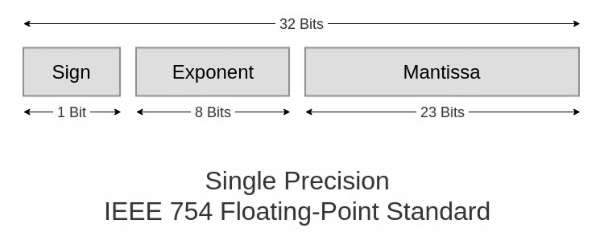
Figure 1: Single Precision IEEE 754 Standard [9]

Sign
The most significant bit of the representation represents the sign of the number, where zero means a positive number, and otherwise it means a negative number

- Exponent
This field tells the hardware how large or small the number is however in floating number the exponent may be positive or negative and we cant afford one additional bit to store the sign of the exponent so instead we add to the exponent number a value of 127 for the 32 bit IEEE floating representation so that negative values becomes unsigned and the 127 value is choosen based on this formula.

bias = 2^{k-1}-1
k = number of exponent bits

- Mantissa (fraction)
This field stores the actual digits, and it is always normalized binary, which always starts with 1, so the implicit leading 1 (hidden bit) does not need to be stored, as it will always be the same, so hardware drops it and saves this bit for a more precise number.

Example 1: Conversion of ${1.5}_{10}$to IEEE 754 32-bit Floating Point Format

Step 1:
The sign of the number is positive, so the sign = 0
Step 2:
Integer part: 1*2⁰=1
Fractional part: 2⁻¹ = 0.5 ≥ 0.5, so put 1 in the 2⁻¹ place,
Then subtract 0.5-0.5 = 0
Binary = 1.1 * 2⁰
Step 3:
Exponent = 0, Bias = 127
Stored exponent = 0 +127 = 127
Step 4:
Mantissa: 1.1 100…

Combining the 3 fields would get the number as shown in Table 1.

Table 1: Single-precision IEEE 754 of (1.5)₁₀
Sign | Exponent | Mantissa
0 | (127)₁₀ | (10000000000000000000000)₂
0 | (01111111)₂ | (10000000000000000000000)₂
(1.5)₁₀ $≡$ 0 01111111 10000000000000000000000

As explained, the floating-point format is not a normal format to use the normal integer arithmetic units on hardware instead, it needs dedicated hardware to do the same operations as fast as possible, and an example of that is this circuit mentioned in Chapter 3, Arithmetic for Computers by David A. Wood [10]
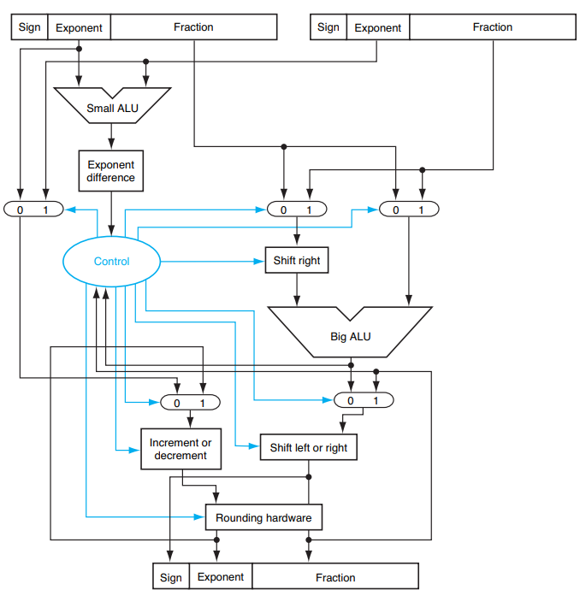
Figure 2: Block diagram of an arithmetic unit dedicated to floating-point addition [10]

Conclusion

Lorem Ipsum is simply dummy text of the printing and typesetting industry. Lorem Ipsum has been the industry's standard dummy text ever since the 1500s, when an unknown printer took a galley of type and scrambled it to make a type specimen book. It has survived not only five centuries.

Acknowledgment

I would like to thank Dr. Heba Draz for her supervision and valuable feedback on this work, and also thank the Electronics Research Institute (ERI) for providing laboratory facilities and resources. This project was conducted as part of the Hardware/Software Co-Design course under the ECIP Internship Program.

References
- IEEE Standards Association, IEEE Standard for SystemVerilog—Unified Hardware Design, Specification, and Verification Language (IEEE Std 1800 2017), Feb. 22, 2018. [Online]. Available: https://rfsoc.mit.edu/6S965/_static/F24/documentation/1800%202017.pdf
- Verification Academy, “UVM runtime phases,” UVM Reference, n.d. [Online]. Available: https://verificationacademy.com/topics/uvm-universal-verification-methodology/functional-verification-of-digital-logic
- Wikipedia, “Random Forest,” Wikipedia, n.d. [Online]. Available: https://en.wikipedia.org/wiki/Random_forest
- Displayr, “Decision Tree Example,” Displayr, n.d. [Online]. Available: https://www.displayr.com/what-is-a-decision-tree
- Kaggle, “Smart Farming Sensor Data for Yield Prediction,” Kaggle Dataset, n.d. [Online]. Available: https://www.kaggle.com/datasets/atharvasoundankar/smart-farming-sensor-data-for-yield-prediction/data
- Accellera, “SystemVerilog UVM Guide,” Accellera Standards, n.d. [Online]. Available: https://www.accellera.org/downloads/standards/uvm
- Xilinx, “FPGA Design Principles,” Xilinx, n.d. [Online]. Available: https://www.xilinx.com/products/design-tools.html
- https://blogs.sas.com/content/iml/2019/11/11/round-to-even.html
- https://www.geeksforgeeks.org/computer-organization-architecture/ieee-standard-754-floating-point-numbers/
- https://pages.cs.wisc.edu/~david/



Floating-point representation on hardware

